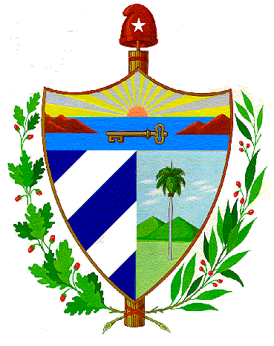
PROVINCIAL ADMINISTRATIVE COUNCIL
PINAR DEL RÍO

Procedure for the comprehensive visits of the Provincial Assembly of Popular Power and the CAP to the base (CAMs Direcciones Administrativas), during the year 2017.

- Objectives

Consolidate a system of work that responds to the current demands in the organization and planning of controls in an integrated manner, allowing compliance with the agreements and resolutions approved by the VII Congress of the Communist Party of Cuba, the decisions of the National Assembly of Popular Power, the Council of Ministers, as well as the updating of the Economic Plans.

Evaluate the fulfillment of the work objectives of the Assembly and the Council of Municipal Administration and Entities, for the current year, on the basis of the approved measurement criteria.

- Scope

Includes subordinate or attached organizational units, Presidents of Assemblies, Vice Presidents, Secretaries, Presidents of Popular Councils, Delegates and all Directors with their Boards of Directors, in addition to other officials, Department and Offices of the People's Power System and Directorates that are not of subordination, but tax the objectives of the territory and the province.

- References

The guide and the control plan that will be used during the visits, will have the approval of the President and will be applied from February 2017, making sure previously that it is of the knowledge of those controlled.

- The plans, programs, norms, legal dispositions and procedures that regulate the fulfillment of the state functions, or defined social object, will be object of control.

- There will be two annual visits to the municipalities, one of them with the intention of a Functional Control of the Direction of the Assembly and the Board of the Administration with a duration of three consecutive days and four months later we will carry out a visit of supervision of one working day.
- In relation to the Provincial Directorates of subordination, there will be two annual hearings, one of a Functional Control of the Board of Directors with a duration of two consecutive days and four months later we will carry out a supervisory visit of one working day.
- The working groups will be organized by the secretariats so that they do not interfere with the functions of the counterparts, defining the day on which the different controls or supervisions will be carried out, based on the proposal of the annual control plan annexed to the model.
- The current work proposal has the purpose of achieving an integrated view of the municipality and the directions, optimizing time, resources and not affecting the dynamics of entities or popular councils, the prior consensus will avoid the coincidence of the proposed dates with fundamental processes, and with Audits or Fiscal Controls.
- Participating in the planned visits are the Permanent Commissions of the Provincial Assembly, both Secretariats, with their work teams, the vice-presidents with the Global Organisms and other provincial directorates that are considered necessary for the control of the territory and the directorates, departments and offices of the Provincial People's Power Headquarters (Security and Protection, Science and Technology Forum, Attention to combatants, Turkish Plan, Cadre, Internal Dependence and Specialists that are considered to be trained, on the day foreseen for the visit or previously, according to the planning conceived in the Annual Work Plan.

- The fundamental method for the development of the visit is the exchange with as many people and groups of workers as possible, in order to verify compliance with the work objectives and indications in the entities of the territory, as well as their impact on the objectives set by the province.

- The surprise visit at night will be carried out on a date that does not necessarily coincide with the controls planned in the annual plan. In it will participate the system of Security and protection of the CAP accompanied by: SEPCAP, DIS, MININT, and members of the Commissions to attend the recreational activities. Collective transport will be used that will leave at 8:00 p.m. for the Municipality or chosen Direction, at the head of this team will be a member of the CAP Security and Protection Office.

- We propose as responsible for this team, the Head of Security and Protection of CAP who will move independently to the municipality or entity subject to control, trying to arrive at least one hour in advance to inform the authorities involved, establishing the procedure to comply with the intended planning.

- The results of this control, before being submitted to the conclusions, should be analyzed in agreement with the authorities of the territory and provincial entities. The evidences will be edited and approved by the Vice-president.

- The Secretariat of the Assembly prepares a general report of the P/Cs visited, which is presented in the conclusions of the visit, reflecting the written information provided by the head of the commission that visited each council.

- The vice-presidents, heads of commissions, officials and directors participating in the visit, will dispatch the result of the evaluated objectives with those directly responsible in the territory (this will be with vice-presidents of CAM, directors of entities, officials, etc,).

- The summary in the municipality will begin at 1.30 pm, with the Direction of the Assembly and the CAM, analyzing the main incidences detected and their causes, evaluating the integrity in the work.

Ernesto Barreto Castillo
President

